Residual correlation shows that European earwigs do not trade off clutch and egg size.
Clint D. Kelly^{1,✉}
¹ Département des Sciences biologiques, Université du Québec à Montréal, Montréal, Canada
✉ Correspondence: Clint D. Kelly <kelly.clint@uqam.ca>

Abstract
Life history theory predicts that clutch and egg size trade off because both traits compete for the same limited resource pool. Tests of this prediction often show a positive phenotypic correlation, probably because some females acquire more resources than others and can produce more and larger eggs. To accurately assess whether a trade-off exists, it is necessary to examine within-individual correlations, since phenotypic correlations can be misleading. I addressed this issue using a multivariate mixed model to decompose the phenotypic correlation between egg number and size in European earwigs (Forficula auricularia) into among-female and within-female (residual) components. I found that earwigs do not trade off clutch and egg size; instead, these traits are positively correlated. This unexpected result is likely due to changes in ovarian structure after laying the first clutch, combined with how limited resources are allocated to fewer developing oocytes in the second clutch. Contrary to expectation, evidence suggests that the among-female correlation is negative. Additionally, I found that second clutches have greater variation in egg size than first clutches, although the average variation in egg size among females is similar across clutches. Further research is needed to clarify the proximate reasons for the tendency of second clutches to have fewer and smaller eggs than first clutches, as well as to identify the proximate and ultimate causes of the greater variation in egg size in second clutches.

Introduction
Maternal investment is allocated between offspring fitness and quantity, with larger eggs generally enhancing offspring fitness (Clutton-Brock 1991). A limited pool of reproductive resources, therefore, requires females to balance investment between the number and quality of eggs produced during a reproductive cycle (Smith and Fretwell 1974; Roff 1992; Fox and Czesak 2000; see also Parker 1982). However, these traits do not always trade off against each other (Roff 1992; Stearns 1992; Bernardo 1996; Fox and Czesak 2000; Hargitai et al. 2005; Cavaleiro and Santos 2014). Or at least, they do not appear to trade off. Positive correlations between traits that should otherwise covary negatively could be due to how individuals acquire resources and subsequently allocate them among competing traits (Reznick et al. 2000). Van Noordwijk and DeJong (1986; see also Reznick et al. 2000) explained that whether we observe positive or negative correlations between fitness-related traits (e.g., egg number or egg size) depends on whether some individuals in a population can acquire more resources than others and thus possess a larger resource pool that can be partitioned to competing traits. Consequently, such variation in acquisition can lead to a positive correlation between traits (e.g., egg number vs. egg size) when measured across individuals within a population, while masking allocation trade-offs within individuals (i.e. Simpson’s Paradox, Simpson 1951), assuming that all individuals follow a similar allocation strategy. This means that females that acquire more reproductive resources can produce more and larger eggs, but must nevertheless trade off size and number.
Careau and Wilson (2017) argue that revealing a trade-off when contrasting processes occur at the among- and within-individual levels requires partitioning the phenotypic correlation between two competing traits into its among- and within-individual components. This can be achieved by repeatedly measuring traits of interest (i.e. egg number and size) for a group of individuals and then using multivariate mixed models to estimate the among- and within-individual correlations. To my knowledge, no study has yet adopted this approach to show that females indeed trade off egg number and size, despite these traits positively correlating across a population of females. I use the approach of Careau and Wilson (2017) here to test the hypothesis that European earwigs (Forficula auricularia) trade off clutch and egg size. F. auricularia is an ideal insect for testing this hypothesis because females lay a clutch of eggs in a subterranean burrow within a short period of time (i.e. hours) (Meunier 2024), but it isnot clear whether females trade off clutch and egg size across multiple clutches [@koch2014]. Females care for eggs and the nymphs for up to 2 weeks post-hatching (Staerkle and Kölliker 2008; Meunier 2024). Earwigs in Quebec, Canada, are semelparous because the harsh environmental conditions extend the incubation and egg-care period beyond the point at which a second clutch is possible (Tourneur 2018). However, females can be induced to lay a second clutch under optimal laboratory conditions. I use this system to test the prediction that if resource allocation to clutches is greater among than within individuals, then the phenotypic and among-individual correlations between egg size and number will be positive, but the within-individual correlation will be negative because individual females trade off egg number for size. Second, I compare the average number and size of eggs across clutches to test whether fitness gains are optimised at a specific egg quantity or quality (e.g., Smith and Fretwell 1974). If so, one trait should not differ between clutches (e.g., egg number), whereas the other (e.g., egg size) is adjusted accordingly (Winkler and Wallin 1987). Alternatively, females laying a second clutch may recognise their low residual reproductive value and, consequently, terminally invest in current reproduction by producing either more or larger eggs in this clutch (Clutton-Brock 1984). Finally, I explore whether eggs in first and second clutches differ in their size variation at the among- and within-female (clutch) levels (e.g. Hargitai et al. 2005).

Methods
I collected adult female earwigs in September and October 2024 in an urban parks (Parc Outremont) in Montréal, Canada. All earwigs were brought into the laboratory, assigned a unique ID, and individually placed in a 90-mm-diameter Petri dish containing a thin layer of moist sand. Females were provided a cotton-plugged water vial and fed TetraMin Tropical fish flakes ad libitum. Females were maintained in an incubator (Percival) at 10°C in constant darkness.
Females were checked daily for oviposition. When a female laid eggs, I recorded the date and collected all eggs from the sand and placed them on filter paper in a new Petri dish. The eggs were then photographed under a Leica S6D stereo microscope (Leica Microsystems Inc., Concord, ON, Canada) at 0.68x magnification using Enersight software (Leica Microsystems Inc., Concord, ON, Canada), which automatically adds a scale bar to the photo. Eggs were then discarded.
To stimulate females to lay a second clutch of eggs, I recreated a brief period of spring where they were allowed to accumulate resources for egg production and replenish their sperm stores. To achieve this, females that had recently oviposited were placed in a new Petri dish containing a cotton-plugged water vial, TetraMin Tropical fish flakes, and a shelter consisting of four 4 cm-long pieces of paper straw (Blowholes, Markham, Canada) glued together. These Petri dishes were placed in a 23 °C incubator with a 12L:12D light: dark cycle. Females were maintained under these conditions for two weeks, at which time a haphazardly chosen stock male from our colony was placed with her. The pair was kept together for a week, after which a new stock male replaced the original male, and that pair was kept together for another week. Females were then transferred to the 10 °C incubator and treated as previously until they laid their second clutch, at which point their eggs were photographed. Females were euthanised by freezing after laying their second clutch, and their pronotum was photographed as described above. Females were then weighed to the nearest 0.01 mg using a Sartorius Secura 224-1S analytical balance. Females were weighed three times, with each weighing bout separated by four days. I used Fiji image analysis software (Schindelin et al. 2012) to measure the length of the female pronotum and the perimeter of each egg to the nearest 0.001 mm. Both traits were measured three times, with each measurement separated by 4 days.

Statistical analysis
I calculated the repeatability of the body mass, pronotum length and egg perimeter measurements using the R package rptR (Stoffel et al. 2017). I entered the trait of interest as the response variable, female ID as a random effect, and assumed a Gaussian distribution. Each analysis was based on 1000 bootstrap samples. The measurements of my three traits were highly repeatable (pronotum length: R [95% CI] = 0.98 [0.97, 0.99]; body mass: R [95% CI] = 0.99 [0.988, 0.996]; egg perimeters in the first clutch: R [95% CI] = 0.977 [0.976, 0.979] and in the second clutch: R [95% CI] = 0.93 [0.926, 0.937] ). I therefore used each female’s mean pronotum lengthand body mass, in addition to the mean egg perimeter for each egg, in all subsequent analyses. The final data set comprised 42 females, each with two clutches: on average, xx eggs in the first clutch and xxx eggs in the second; the total number of egg-size measurements included in the analysis was 3599.
I reduced the two measurements representing body size (pronotum length and body mass) to a single value (PC1) by performing a principal components analysis (PCA) on the correlation matrix of standardized measurements using the prcomp function in the stats package in R (R Core Team 2025). The first PC accounted for 60.8% of the variation. I also standardised female body mass relative to body size using the scaled mass index procedure of Peig and Green (2009, 2010; see also Kelly et al. 2014).
I tested the prediction that egg number and egg size trade off within females using a Bayesian multivariate linear mixed-effects model (brms package, Bürkner (2017)). Egg number and egg perimeter were entered as scaled response variables, and res_cor was set to TRUE to estimate the within-individual (residual) correlation (r_{within}) between egg number and egg size. I assumed a Gaussian error distribution for both traits to permit the calculation of within-female residuals. Clutch number (first or second) was entered as a fixed effect to test whether the two clutches differed in egg number or egg size. This model also included female pronotum length, a proxy for body size, as a continuous covariate because body size generally correlates with fecundity in insects (Honek 1993). Female ID was included as a random effect via the term (1|a|id), ensuring that random effects were correlated within each female. I assessed which of the four measures of female body size (pronotum length, body mass, PC1, or scaled mass) provided the greatest explanatory power by running four models, each with a different measure, and then comparing them, in addition to a null model without a size measure, using leave-one-out cross-validation (LOO) (Vehtari et al. 2017). Pronotum length, body mass, and scaled mass were scaled (mean = 0, sd = 1) before analysis. The model that included pronotum length as a continuous covariate provided the best fit (Expected Log Predictive Density (ELPD) = -6749.35; Table S2). Because *brms* estimates residual variation on the log scale, I back-transformed these values for biological interpretation by exponentiating and squaring them. Standard deviation units of random effects were squared to calculate the variances. I report the phenotypic (r_{p}), among- (r_{among}), and within- (residual, r_{within}) female correlations and their associated 95% credible intervals (CrIs) from the model.
I examined whether the first (range: xx -xx eggs) and second (range: xx - xx eggs) clutches of eggs differed in egg size variation among (V_{among}) and within (V_{within}) females by constructing a univariate hierarchical linear mixed-effects model with scaled mean egg perimeter as the response variable, clutch (first or second) as a categorical fixed effect, and female pronotum length as a continuous covariate. I also included, as random effects, an uncorrelated random intercept for each clutch per female. In the dispersion part of the model, I included clutch as a fixed effect to estimate the within-individual (i.e. residual) variance in egg size for each clutch. I then tested whether the first and second clutch differed in egg size at the among- and within-female levels.
Bayesian mixed models were run for 10000 iterations (3000 warm-up iterations) across 6 chains, with a thinning interval of 2 (total post-warm-up samples = 21,000). I used weakly informative normal priors (N (0,10)) for fixed effects and positively bound exponential (1) priors for random effects in multivariate models. The univariate hierarchical mixed models were run using default priors. I performed posterior predictive checks to ensure adequate model fits, while trace plots confirmed that models converged with low among-chain variability (Rhat = 1.00). I report posterior means with 95% credible intervals (CrIs) for all parameter estimates, where inference was based on CrIs that did not include zero.

Results
I did not support the prediction that egg number and egg size positively correlate either phenotypically (r_{p} [95% CrI] = -0.08 [-0.36, 0.22]; Figure 1) or among females (r_{among} [95% CrI] = -0.13 [-0.41, 0.17]). Contrary to prediction, egg number and size were positively, rather than negatively, correlated at the within-individual level (r_{within} [95% CrI] = 0.06 [0.03, 0.09]).
I found that second clutches ($\overset{‾}{x}$ = 34.14 ± 17.17 eggs, range: 1 - 69 eggs, n = 42 clutches) were, on average, smaller than first clutches ($\overset{‾}{x}$ = 51.55 ± 16.13 eggs, range: 21 - 86 eggs, n = 42 clutches; multivariate mixed model: Estimate [95% CrI] = -0.68 [-0.73, -0.63]). Similarly, egg size was smaller, on average, in second clutches ($\overset{‾}{x}$ = 3.41 ± 0.20 mm, range: 3.11 - 4.11 mm) versus first clutches ($\overset{‾}{x}$ = 3.54 ± 0.21 mm, range: 3.10 - 3.93 mm; Estimate [95% CrI] = -0.92 [-0.96, -0.88]). These findings suggest that larger clutches had, on average, larger eggs, which supports the aforementioned positive within-female correlation. Female pronotum length (body size) was not correlated with either clutch (Estimate [95% CrI] = 0.06 [-0.18, 0.30]) or egg (Estimate [95% CrI] = -0.03 [-0.24, 0.16]) size.

I found high among- and within-individual variation for egg size (among: ; within: ) and egg number (among: ; within: ). Egg size (R [95% CI] = 0.40 [0.21, 0.57]) and clutch size (R = 0.03 [0.0, 0.32]) are significantly repeatable.
There was no difference in egg size variation between first and second clutches among females ($Δ$V_{among} [95% CrI] = 0.11 [-0.39, 0.65]; Figure 2), but within-clutch egg size variation was smaller in first than in second clutches ($Δ$V_{within} [95% CrI] = -0.15 [-0.18, -0.12]; Figure 2). Within-clutch egg size variation (i.e. standard deviation of egg size per clutch) was related to clutch size in first (Spearman’s correlation: $ρ$ = 0.36, p=0.020) but not in second ($ρ$ = -0.14, p=0.401) clutches.

Discussion
My multivariate repeated-measures analysis of clutch and egg size found no evidence that female European earwigs trade off egg number and egg size. Despite failing to support general life history theory (Roff 1992; Stearns 1992) and contradicting the results of a previous study in this species (Koch and Meunier 2014), it is the first, to my knowledge, to partition the phenotypic correlation between egg number and size into its among- and within-individual components. Although many studies have supported the prediction that egg number and size trade off, some have not (Roff 1992; Fox and Czesak 2000). Because these previous studies relied on phenotypic correlations to examine the relationship between egg number and size, it is not possible to assess the extent to which this prediction is empirically supported across taxa, given the propensity for phenotypic correlations to generate spurious and misleading associations. For example, Koch and Meunier (2014) showed that, in an Italian population of F. auricularia, residual egg number and residual egg size (adjusted for female body mass) are negatively correlated at the phenotypic level. However, these findings must be treated with caution; they are based on pseudo-replicated data (both clutches for each female were pooled and treated as independent), a situation that can lead to Simpson’s Paradox (Simpson 1951) and spurious correlations because within-individual relationships are masked by among-individual variation. Indeed, I also observed no correlation at the phenotypic level. However, by partitioning the variance into its among- and within-individual components, I found that females do not make the predicted trade-off. Rather, I found evidence that egg number and size are positively correlated within females.

My study revealed that second clutches comprised, on average, fewer and smaller eggs than first clutches. This finding refutes the terminal investment hypothesis, as female second clutches were neither, on average, larger nor comprised larger eggs. My findings, however, are consistent with those of another study of a Montreal population (Tourneur and Gingras 1992) and with those of another study involving an Italian population (Koch and Meunier 2014). Tourneur and Gingras (1992) proximally attributed the fewer, smaller eggs in second clutches to ovarian structure and function in F. auricularia. Specifically, they suggested that second clutches are smaller than first ones because some (or all) oviarioles become non-functional and thus produce no eggs after the first clutch. This reduction in ovariole number might explain the smaller second clutches that I observed here, but why did females not produce larger eggs and thus exhibit the expected number-size trade-off? One possibility is that my females had a proportionally shallower resource pool from which to build eggs for the second clutch, for example, because they had less time to accumulate reproductive resources for it than for the first. Females in the wild presumably spent from mid-spring to mid-fall acquiring resources for reproduction, while they had only about a month in the laboratory to do so for the second one. Hence, by partitioning their proportionally fewer resources equally to each of the fewer functional ovarioles during their second bout of oogenesis, females produced fewer and smaller eggs, on average, than in their first clutches. Inspection of Figure 1 shows that some females exhibit the expected trade-off, suggesting that at least some were able to acquire enough resources to produce larger eggs in their smaller second clutch. The above proximate explanation assumes that females allocate resources equally to each functional ovariole, rather than clutch size being a consequence of the resource pool size, and that females with more functional ovarioles acquire more resources than those with fewer. These assumptions require empirical testing. .
Producing fewer but smaller eggs seems like a costly fitness decision since, in most animal taxa, larger eggs generally have a higher probability of hatching and producing larger offspring, which, in turn, have a higher probability of surviving to adulthood (e.g. birds: Williams 1994; amphibians: Ficetola and De Bernardi 2009; reptiles: Nelson et al. 2004; fish: Einum and Fleming 2000). Although this does not appear to be the typical case in insects (Church et al. 2019), larger eggs are more likely to hatch and to produce larger nymphs in F. auricularia (Koch and Meunier 2014), so egg size appears to ultimately have some positive fitness effects for the mother and offspring in this species. Therefore, the smaller earwig eggs in the second clutch by female F. auricularia might have reduced fitness, except for two extenuating factors. First, maternal care in this species likely improves the survival chances of smaller eggs (Kölliker 2007; e.g., Boos et al. 2014), and the poor outcomes commonly associated with smaller nymphs might be mitigated by maternal provisioning (Staerkle and Kölliker 2008). Second, smaller eggs tend to hatch faster as development time is positively related to egg size across animal species (Shine 1978). This would be advantageous if a second clutch is produced later in the reproductive season, such as mid-winter, because it would mean the eggs would hatch at a time of year (e.g., late-winter) that allows nymphs to emerge at an optimal time in spring. Empirical evidence, however, suggests that time-to-hatch is unrelated to egg mass in at least one (Italian) population of F. auricularia (Koch and Meunier 2014). This latter population, however, is from a more temperate locale than Montreal, and experiences a milder climate and thus perhaps less intense selection on reduced development time. Further research is needed to determine the ultimate consequences of females producing smaller clutches with smaller eggs. This question is becoming increasingly important, as climate warming may allow semelparous populations in Montreal-like climates to produce second clutches more frequently.
Among-female variation in average egg size was similar in both clutches, meaning that females exhibited similar levels of individuality in average egg size in both clutches. The repeatability of average egg size between clutches could indicate that egg size is a significantly heritable trait (e.g. Falconer and MacKay 1996). This would not be surprising as egg size has been demonstrated to be significantly heritable in a variety of insect species, including Callosobruchus chinensis seed beetles (Yanagi et al. 2006), Parnara guttata guttata butterflies (Seko et al. 2006), Lobesia botrana moths (Torres-Vila et al. 2012), and spruce budworm (Choristoneura fumiferana) (Harvey 1983).
In contrast, I found evidence that variation in egg size within a clutch was greater in second clutches than in first clutches, the opposite of the pattern observed in birds. (e.g., Yosef and Zduniak 2008). Empiricists have argued that lower variation in egg size within a clutch is probably linked to environmental factors and food availability. For example, desert finches (Rhodopsiza obsoleta) produced similar-sized eggs when environmental conditions were stable (Yosef and Zduniak 2008), collared flycatchers (Ficedula albicollis) produced larger eggs with the laying sequence in favourable conditions (Hargitai et al. 2005), and blue tits (Parus caeruleus) in better nutritional condition had clutches with less variation in egg size (Nilsson and Svensson 1993). Although information on intraclutch egg-size variation and its proximal drivers is scarce in insects, the same principles may apply, given that female earwigs in my study had less time to accumulate resources and maximise their body condition before producing their second clutch. If true, then females might have allocated resources maximally to the eggs in their first clutch, following an individual allocation strategy based on intrinsic factors such as body condition. This strategy would produce individual-specific egg sizes that are consistent across eggs within a clutch. In second clutches, by contrast, females might have allocated an optimal (but smaller) amount of resources to each oocyte until the last few oocytes, when they had fewer resources remaining and thus produced a few significantly smaller eggs. I did not record laying order in this study and therefore cannot assess whether larger eggs were laid first or last. Within-clutch variation in egg size is adaptive in birds. For example, larger eggs later in the egg-laying sequence may be a brood-survival strategy that counteracts the effects of hatching asynchrony, whereas smaller eggs later in the laying sequence may be a brood-reduction strategy (Slagsvold et al. 1984). However, it is unknown whether variation in egg size serves an equivalent adaptive function in insects that express maternal care.
In conclusion, by partitioning variance into its among- and within-individual components, I found that female European earwigs do not trade off clutch and egg size. Instead, I found a positive correlation between egg number and size within females. My results suggest that proximate mechanisms may constrain individuals’ ability to make trade-offs, such as when resources are equally allocated among eggs even though females possess limited resource reserves.I also discovered that second clutches consist of eggs with a more variable size than first clutches, but the among-female variation in average egg size was similar between the two clutches.

Data availability
Data are available through the OSF repository at 10.17605/OSF.IO/MFJ8E.

Author contributions
CDK collected and analyzed the data, and wrote the manuscript.

Funding
The study was funded by a Discovery Grant from the Natural Sciences and Engineering Research Council of Canada (NSERC).

Conflict of Interest
I declare no conflict of interest.

Acknowledgements
I thank Andréanne Nault and Clara Smythe for assistance in animal care and data collection.

References
Bernardo, J. 1996. The particular maternal effect of propagule size, especially egg size: Patterns, models, quality of evidence and interpretations. Am Zool 36:216–236.
Boos, S., J. Meunier, S. Pichon, and M. Kölliker. 2014. Maternal care provides antifungal protection to eggs in the european earwig. Behav Ecol 25:754–761.
Bürkner, P.-C. 2017. brms: An R package for Bayesian multilevel models using Stan. Journal of Statistical Software 80:4308.
Careau, V., and R. Wilson. 2017. Of uberfleas and krakens: Detecting trade-offs using mixed models. Integr Comp Biol 57:362–371.
Cavaleiro, F. I., and M. J. Santos. 2014. Egg number-egg size: An important trade-off in parasite life history strategies. Int J Parasitol 44:173–182.
Church, S. H., S. Donoughe, B. A. S. de Medeiros, and C. G. Extavour. 2019. Insect egg size and shape evolve with ecology but not developmental rate. Nature 571:58–62.
Clutton-Brock, T. H. 1984. Reproductive effort and terminal investment in iteroparous animals. Am Nat 123:212–229.
Clutton-Brock, T. H. 1991. The Evolution of Parental Care. Princeton University Press.
Einum, S., and I. A. Fleming. 2000. Highly fecund mothers sacrifice offspring survival to maximize fitness. Nature 405:565–567.
Falconer, D. S., and T. F. C. MacKay. 1996. An Introduction Quantitative Genetics. Pearson Education Limited, Essex, England.
Ficetola, G. F., and F. De Bernardi. 2009. Offspring size and survival in the frog rana latastei: From among-population to within-clutch variation. Biol J Linn Soc 97:845–853.
Fox, C. W., and M. E. Czesak. 2000. Evolutionary ecology of progeny size in arthropods. Annu Rev Entomol 45:341–369.
Hargitai, R., J. Török, L. Tóth, G. Hegyi, B. Rosivall, B. Szigeti, and E. Szöllősi. 2005. Effects of environmental conditions and parental quality on inter-and intraclutch egg-size variation in the collared flycatcher (ficedula albicollis). The Auk 122:509–522.
Harvey, G. T. 1983. Environmental and genetic effects on mean egg weight in spruce budworm (lepidoptera: tortricidae). The Canadian Entomologist 115:1109–1117.
Honek, A. 1993. Intraspecific variation in body size and fecundity in insects: A general relationship. Oikos 483–492.
Kelly, C. D., B. Tawes, and A. Worthington. 2014. Evaluating indices of body condition in two cricket species. Ecology and Evolution 4:4476–4487.
Koch, L. K., and J. Meunier. 2014. Mother and offspring fitness in an insect with maternal care: Phenotypic trade-offs between egg number, egg mass and egg care. BMC Evol Biol 14:125.
Kölliker, M. 2007. Benefits and costs of earwig (forficula auricularia) family life. Behav Ecol Sociobiol 61:1489–1497.
Meunier, J. 2024. The biology and social life of earwigs (dermaptera). Annu Rev Entomol 69:259–276.
Nelson, N. J., M. B. Thompson, S. Pledger, S. N. Keall, and C. H. Daugherty. 2004. Egg mass determines hatchling size, and incubation temperature influences post‐hatching growth, of tuatara sphenodon punctatus. J Zool 263:77–87.
Nilsson, J. ‐Å., and E. Svensson. 1993. Causes and consequences of egg mass variation between and within blue tit clutches. J Zool 230:469–481.
Parker, G. A. 1982. Why are there so many tiny sperm? Sperm competition and the maintenance of two sexes. J Theor Biol 96:281–294.
Peig, J., and A. J. Green. 2009. New perspectives for estimating body condition from mass/length data: The scaled mass index as an alternative method. Oikos 118:1883–1891.
Peig, J., and A. J. Green. 2010. The paradigm of body condition: A critical reappraisal of current methods based on mass and length. Funct Ecol 24:1323–1332.
R Core Team. 2025. R: A language and environment for statistical computing. Vienna, Austria.
Reznick, D., L. Nunney, and A. Tessier. 2000. Big houses, big cars, superfleas and the costs of reproduction. Trends Ecol Evol 15:421–425.
Roff, D. 1992. Evolution of Life Histories: Theory and Analysis. Chapman & Hall, Inc., New York, NY.
Schindelin, J., I. Arganda-Carreras, E. Frise, V. Kaynig, M. Longair, T. Pietzsch, S. Preibisch, C. Rueden, S. Saalfeld, B. Schmid, J.-Y. Tinevez, D. J. White, V. Hartenstein, K. Eliceiri, P. Tomancak, and A. Cardona. 2012. Fiji: An open-source platform for biological-image analysis. Nat Methods 9:676–682. Max Planck Institute of Molecular Cell Biology; Genetics, Dresden, Germany.
Seko, T., T. Miyatake, S. Fujioka, and F. Nakasuji. 2006. Genetic and environmental sources of egg size, fecundity and body size in the migrant skipper, parnara guttata guttata (lepidoptera: hesperiidae). Popul Ecol 48:225–232.
Shine, R. 1978. Propagule size and parental care: The “safe harbor” hypothesis. J Theor Biol 75:417–424.
Simpson, E. H. 1951. The interpretation of interaction in contingency tables. Journal of the Royal Statistical Society: Series B (Methodological) 13:238–241.
Slagsvold, T., J. Sandvik, G. Rofstad, Ö. Lorentsen, and M. Husby. 1984. On the adaptive value of intraclutch egg-size variation in birds. The Auk 101:685–697.
Smith, C. C., and S. D. Fretwell. 1974. The optimal balance between size and number of offspring. Am Nat 108:499–506.
Staerkle, M., and M. Kölliker. 2008. Maternal food regurgitation to nymphs in earwigs (forficula auricularia). Ethology 114:844–850.
Stearns, S. C. 1992. The Evolution of Life Histories. Oxford University Press.
Stoffel, M. A., S. Nakagawa, and H. Schielzeth. 2017. RptR: Repeatability estimation and variance decomposition by generalized linear mixed‐effects models. Methods Ecol Evol 8:1639–1644.
Torres-Vila, L., E. Cruces-Caldera, M. Rodrı́guez-Molina, and L. Cauterruccio. 2012. Host plant selects for egg size in the moth lobesia botrana: Integrating reproductive and ecological trade-offs is not a simple matter. Pp. 145–167 in L. Cauterruccio, ed. Moths: Types, ecological significance and control methods. Nova Science Publishers, New York, NY.
Tourneur, J.-C. 2018. Factors affecting the egg-laying pattern of forficula auricularia (dermaptera: Forficulidae) in three climatologically different zones of north america. The Canadian Entomologist 150:511–519.
Tourneur, J.-C., and J. Gingras. 1992. Egg laying in a northeastern North American (montréal, québec) population of forficula auricularia l. (Dermaptera: Forficulidae). The Canadian Entomologist 124:1055–1061.
Van Noordwijk, A. J., and G. de Jong. 1986. Acquisition and allocation of resources: Their influence on variation in life history tactics. Am Nat 128:137–142.
Vehtari, A., A. Gelman, and J. Gabry. 2017. Practical Bayesian model evaluation using leave-one-out cross-validation and WAIC. Statistics and Computing 27:1413–1432.
Williams, T. D. 1994. Intraspecific variation in egg size and egg composition in birds: Effects on offspring fitness. Biol Rev Camb Philos Soc 69:35–59.
Winkler, D. W., and K. Wallin. 1987. Offspring size and number: A life history model linking effort per offspring and total effort. Am Nat 129:708–720.
Yanagi, S., T. Oikawa, and T. Miyatake. 2006. Heritability and genetic correlation estimates for egg size and number in callosobruchus chinensis (coleoptera: bruchidae). Ann Entomol Soc Am 99:364–368.
Yosef, R., and P. Zduniak. 2008. Variation in clutch size, egg size variability and reproductive output in the desert finch (rhodospiza obsoleta). J Arid Environ 72:1631–1635.

##Figures
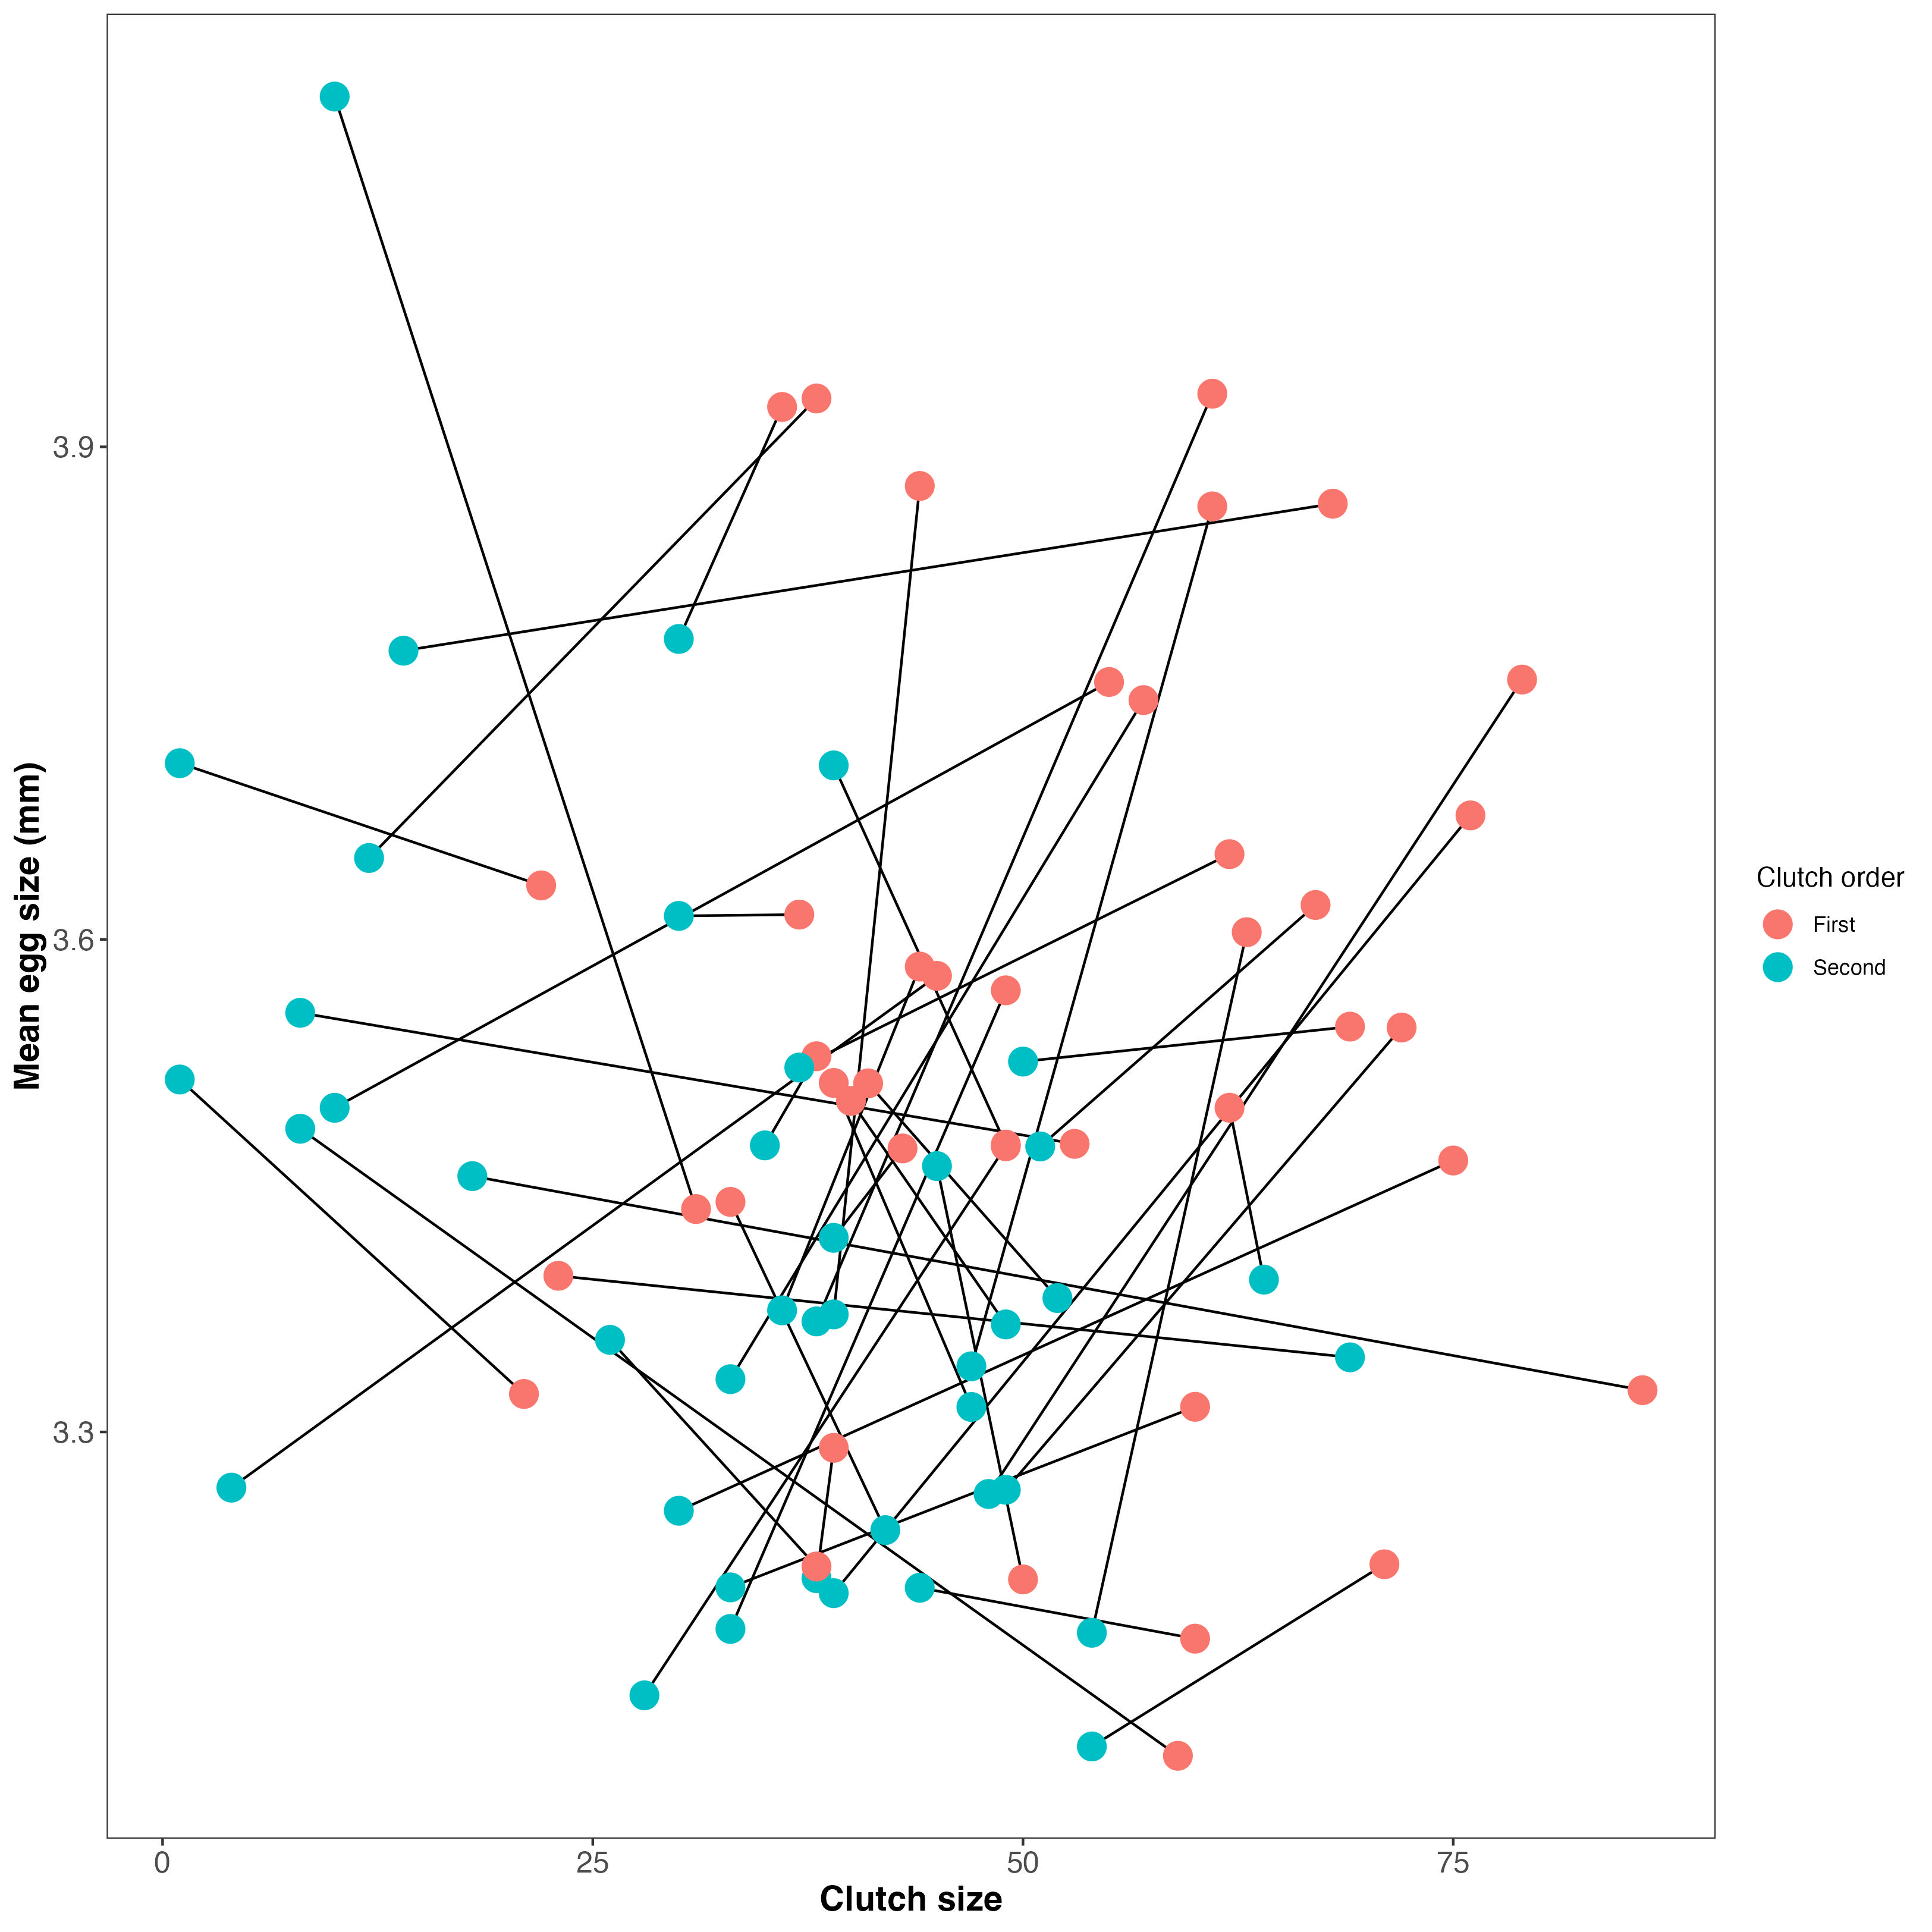
Figure 1: Mean egg perimeter (mm) plotted against clutch size for the first (salmon) and second (blue) clutches of n = 42 female European earwigs (F. auricularia). Data are raw values.

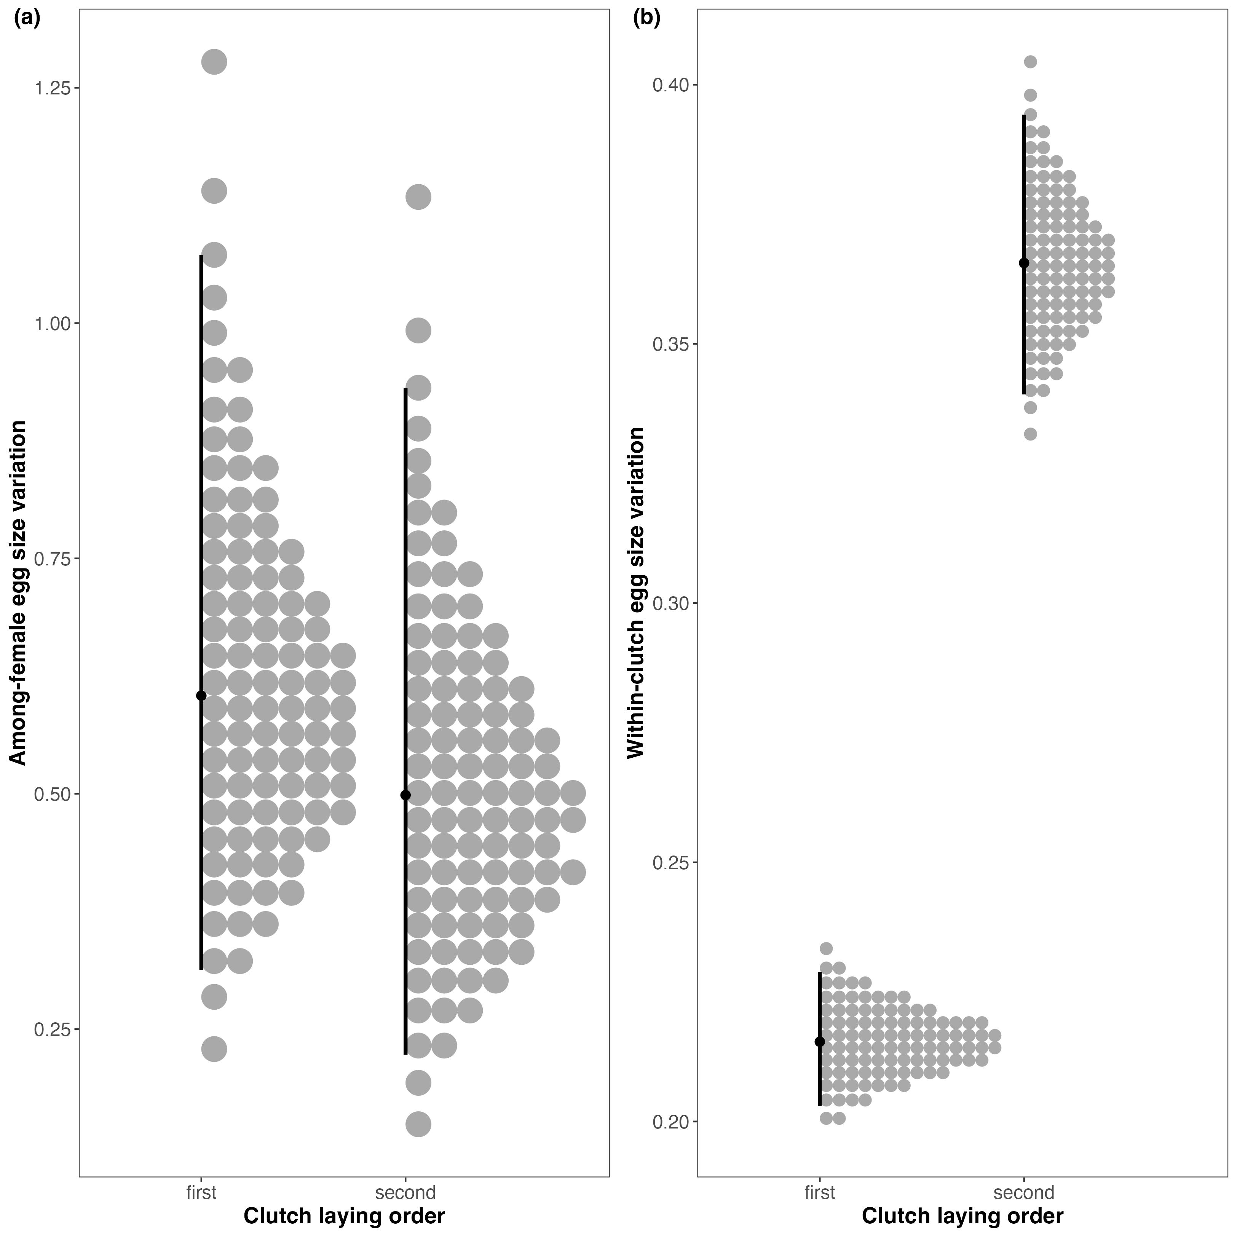
Figure 2: (a) Among and (b) within-female egg size variation in the first and second clutches of n = 42 female European earwigs (F. auricularia).

